**Experiment No : 04**

**Title : Write a Python program to perform  following operations on list:**

**a) Create**

**b) Access**

**c) Update**

**d) Delete**

**Problem Statement:**

Create a list of 5 strings, and perform various operations like create, access, update, delete, len, etc.

**Theory :**

Python has a set of built-in methods that you can use on lists/arrays.

|  |  |
| --- | --- |
| Method | Description |
| [append()](https://www.w3schools.com/python/ref_list_append.asp) | Adds an element at the end of the list |
| [clear()](https://www.w3schools.com/python/ref_list_clear.asp) | Removes all the elements from the list |
| [copy()](https://www.w3schools.com/python/ref_list_copy.asp) | Returns a copy of the list |
| [count()](https://www.w3schools.com/python/ref_list_count.asp) | Returns the number of elements with the specified value |
| [extend()](https://www.w3schools.com/python/ref_list_extend.asp) | Add the elements of a list (or any iterable), to the end of the current list |
| [index()](https://www.w3schools.com/python/ref_list_index.asp) | Returns the index of the first element with the specified value |
| [insert()](https://www.w3schools.com/python/ref_list_insert.asp) | Adds an element at the specified position |
| [pop()](https://www.w3schools.com/python/ref_list_pop.asp) | Removes the element at the specified position |
| [remove()](https://www.w3schools.com/python/ref_list_remove.asp) | Removes the first item with the specified value |
| [reverse()](https://www.w3schools.com/python/ref_list_reverse.asp) | Reverses the order of the list |
| [sort()](https://www.w3schools.com/python/ref_list_sort.asp) | Sorts the list |

**Code :**

fruits_lst = []    # create list

n = *int*(input("Enter number of elements : "))

for i in range(0, n):

    ele =input()

    fruits_lst.append(ele)

print('Original list of fruits is : ',fruits_lst)                                 # Access List

print()

a=input('enter new elment to add in list ')

fruits_lst.append(a)                                                             # Add new elements in list

print('list of fruits  after adding new element is : ',fruits_lst)

print()

b=*int*(input('enter index no of element to delete from a list '))

del fruits_lst[b]                                                                # Delete element of string

print('list of fruits after deleting element is : ',fruits_lst)

l=len(fruits_lst)

print('length of list is ',l)

**Output :**

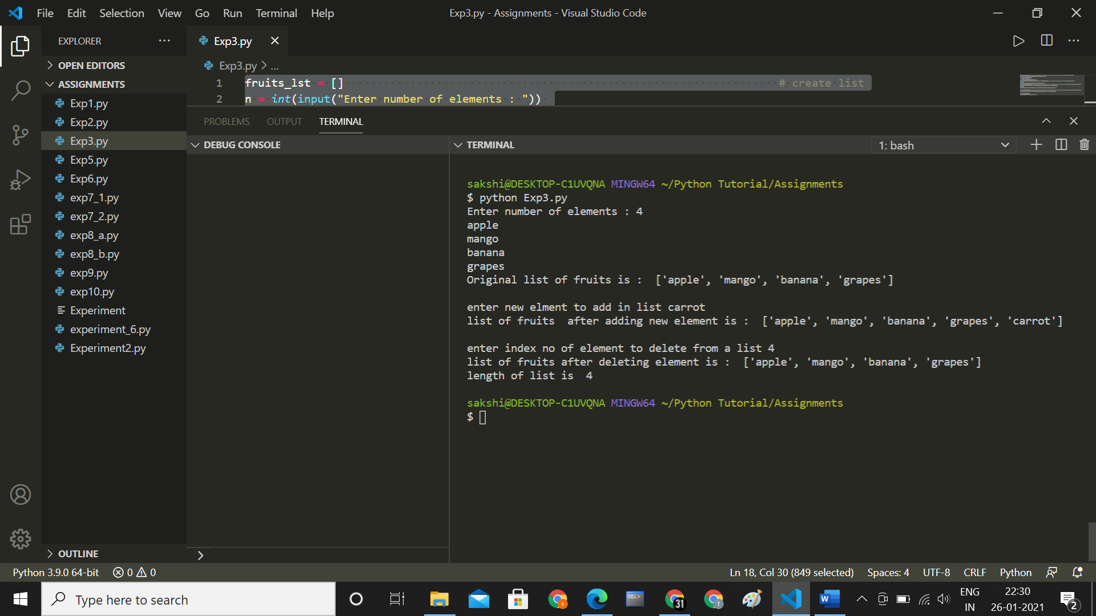

**Conclusion :**

**Thus we have understood how to perform list operations**